Project Proposal in

**Fitness care system**



Dhirendra Thakur

Sec – B

**Computing Project**

**Level 5 Diploma in Computing**

**Softwarica College of IT & E-Commerce**

**Kathmandu, Nepal**

**9Th April 2019**

**Submitted to Niman Maharjan**

Table of Contents

Table of Figure 3

Introduction: 4

Chapter 1 4

**1**. Justification of project 4

Chapter 2: 5

Chapter 3 6

Chapter 4: 8

4. Work Breakdown Structure (WBS)/Scheduling 8

Description of milestone: 11

**4.3 Scheduling/ Gantt chart:** 12

Chapter 5 14

Chapter 6 15

Chapter 7 17

Conclusion: 17

Chapter 8: 17

Referencces: 17

# Table of Figure

Figure 1: Waterfall Model 6

Figure 2: WBS table for the project 8

Figure 3: Time estimation for the project 9

Figure 4: Days division for task 12

Figure 5: Gantt chart for project 13

Figure 6: Likelihood 14

Figure 7: Consequence 14

Figure 8: Risk Consequences 15

Figure 9: MBS on GitHub 15

Figure 10: Tree structure of MBS 16

# Introduction:

Being fit and haveing an awesome body is becoming commen in context of Nepal. Exercise is on of the factor that leads to human being to fitness. From the past year fitness is being praticed. Being fit means having less chance of diseases or illness. There are different exercise for the different people according to their body type. Fitness contain gym, aerobic, yoga etc.

Exercise is perform to reduce stress and get rid of drepress, anxiety. Stress hormon like cortisol and adrenaline can be reduce by the help of exercise. Serotonin, neurotransmitter can increase in brain which help to improve focus and clarity.

# Chapter 1

# **1**. Justification of project

**1.1** Background of project:

Fitness care system is a desktop application where user can get information about workout lists according to their body size directly from trainer. As well as they can pay their monthly fees for the club. Although its, desktop application internet service can available for the user. For the personal trainer user have to login the system which can be easily availabe from the google or specific web sites.

Fitness care system is user friendly that means user will not get hard time to use system. User can get new workout tips as well as other information like about diet from the system. To create this system I have used c# for the programing and SQL Server for the database.

1.2 Problem Statement:

Lots of problem occurs during the exercise time where you don’t have any idea about workout and about what they are doing. You keep on doing the same workout for long but you didnit get result that you have expected. You may get hurt from the wrong workout or with the bad posture.

So the current system will solve the problems. It will help you to get new workout plan for your body with the good workout position or posture. Information about deit can be found from the system.

**1.3** Description of project

**1.3.1 Fatures of system:**

* User can register and login to system

User can register from register form and login to the system from the login form then after login user can get proper diet plan and workout plan.

* User can pay bill

User can pay bill to the club through online.

* User can get workout plan

By the help of system user can get workout paln accourding to their body type.

* User can get diet plan

According to user body type they can choose deit plan wether they wan to loss their weight or gain muscle.

* Admin are only allow to edit update and delete the data of user list.

# Chapter 2:

**2.** Project scope

**2.1** Scope and Limitations

**Scope:**

Fitness care system is desktop application for the club where admin can enter the user details and user can choose the different workout exercise as well as they can choose diet plan.

**Limitation:**

The limitation for the system are given below:

* User maynot find application easily.
* May be user didn’t have desktop or laptop to operate application.

**2.2** Aims and Objectives

Aims of the system are:

* Get onto a healthy nutration paln.
* To provide high quality training and coach facilities.
* To empower people to improve their own physical and mental being
* To provide online supplement as well as online payement

Objective of system:

1. To make best use of our club resources
2. To provide best coaching and training to the user
3. To list down the details of user and their training
4. To save time for paying money

The objective of the project is guid the user to get healty and got awesome body which they have been dream for. It will give all the information about the workout paln and diet paln to the user as well as some of specific pwerful supplement for the user.

# 

# Chapter 3

**3.** Development methodology

**3.1** Methodology used:

For this project I have used Waterfall approach. It is earliest software development life cycle approach which is very simple to understand and use. In this model you have to finish one step to jump to another step besically it is done step by step. Waterfall model is divided into 6 different phases. Those are requirement analysis, system design, implementation, testing, deployment, maintenance

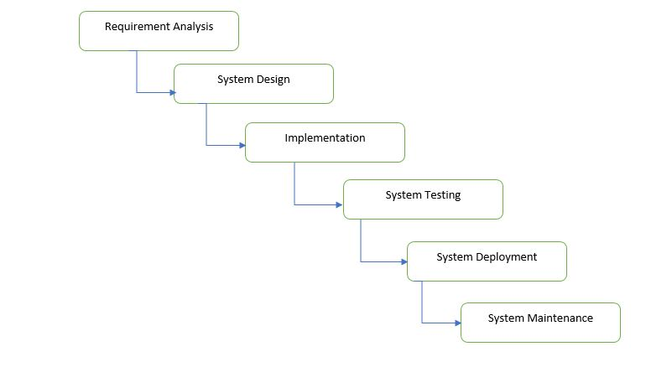

Figure : Waterfall Model

In waterfall model all the requirement is gathered in requirement analysis stage then system design is prepared by studing the requirement. From system design phase implemntation is applied and small program is developed then the system is senf to testing phase where all the possible testing is occurred. After funvtional and non functional testing system is sent to client environment in system deployment phase. After installing in client environment necessary update is done according to the client requirement in the maintenance phase.

Advantange of waterfall model:

* It allows for departmentalization and managerial control.
* Simple and easy to understand and use.
* Easy to manage due to the rigidity of the model – each phase has specific deliverables and a review process.
* Phases are processed and completed one at a time.
* Works well for smaller projects where requirements are very well understood.

For this waterfall model suit because it help to develop project step by step. It may be difficult to change design, waterfall approach lends itsself well to alteration early in the life cycle. It is suited for the smaller project because this project requirement is well defined.

**3.2** Design Pattern.

Design pattern is a repeatable solution to a commanly occuring problem to the system design. It is not a completed design pattern which can be directly transformed into code.

**Use of Design pattern:**

Design pattern helps to increace the development process by providing tested. Reusing design pattern can help in preventing subtle issues that can cause major problem and improve code readbility for coders.

For this project I am using MVC design pattern. It is most used framework in software development and its stands for Model viw controller.

Model: Model is the central component of the application as well as it is the application dynamic data structure. It is independent of the user interface. It helps to manage data, logic and rules of application.

View: It is a representation of information such as a chart, diagram or table. It is the user interface of application. View observe the model and and update itself.

Controller: Controller accepts input and it convert ti command for the model or view. The controller job to update the model when neccressary (if user want to change).

MVC pattern is suited to this project because it is faster development process. To get process fast MVC helps to separate input, processing and output of an application. During the coding controller receives all request for the application then instruct the model to prepare any information required by views.

**3.3** System Architecture**:**

It is a conceptual model that defines the structure, behaviour and view of a system. It consiste of system component and the sub system developed. It work together to implement the overall system. Three-tier architecture is a software design pattern and architecture. I am using three-tier architecture for this project.

**Presentation Tier:** It occupies the top level and displays information of the services available. It communicates with other tiers by sending results to other tiers in a network.

**Application Tier**: It is middle tier as well as logic tier which is pulled from the presentation tier. It controls application functionality by performing detailed processing.

**Data Tier**: It is the database servers where information are stored and retrieved. Data are kept independent of application servers or business logic.

For this project I would use n-tier because it usually built around the database and many application in business. In this architecture code is arranged so that data enters the top layer and work its way down to each layer until its reach bottom i.e. database.

Because of these point I am using this architecture:

* Maintainable
* Testable
* Easy to assign separate roles
* Easy to update and enhancce layes separately

# Chapter 4:

# 4. Work Breakdown Structure (WBS)/Scheduling

**4.1** Work Breakdown Structure:

WBS is a key project deliverable that organize the teams work into managable section. It helps to breakdown project into smaller components. Its elements may be product, data, service or any combination. It also provide neccessarry framework for detailed cost estimation.

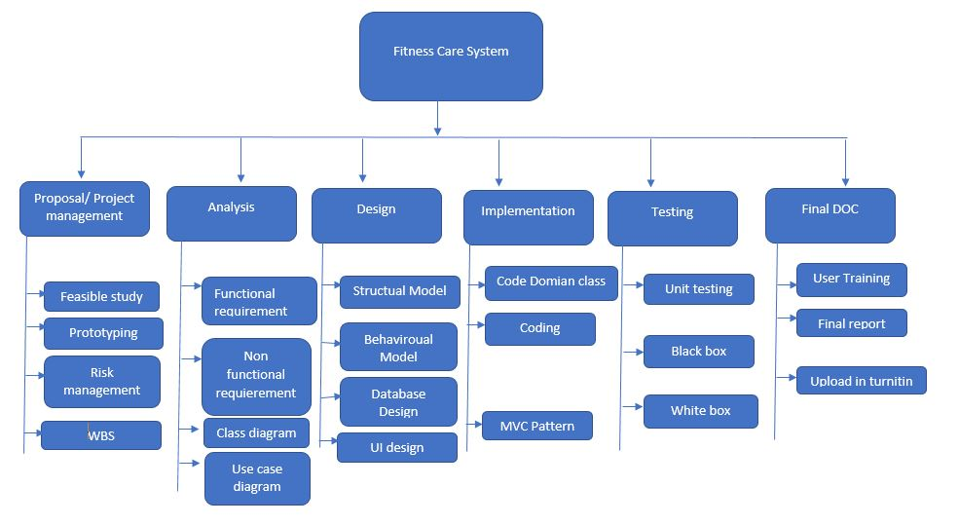

Figure : WBS table for the project

**Time estimation:**

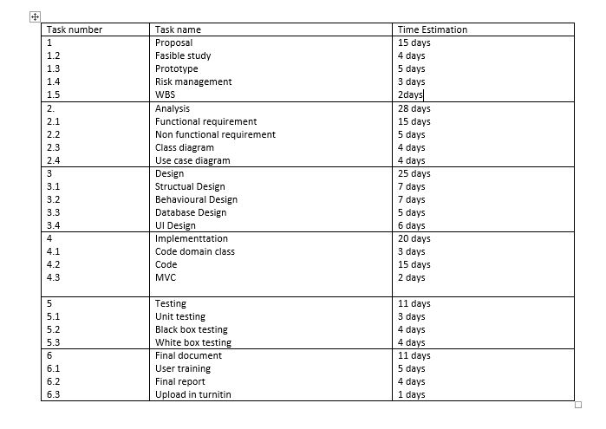

Figure : Time estimation for the project

**4.2** Milestone:

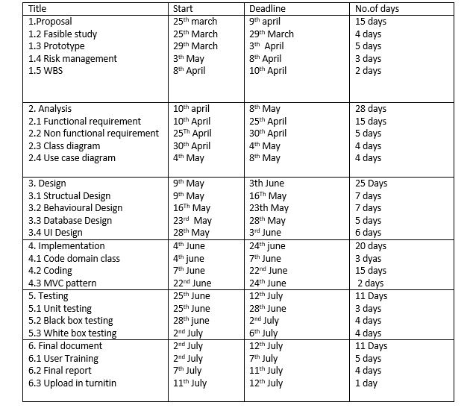

# Description of milestone:

**Proposal/ Project management:**

For the proposal/ project management I have allocate 15 days where 4 days for fasible study because I have to list all the possible class and object for the project, 5 days for prototyping so that it will make easy to draw the project, 3 days for risk management because possible way to solve the risk and 3 days for WBS (workbreak down structure) because it help to seprate the task in small pieaces.

**Analysis:**

I have allocated 28 days for this task where 15 days for functional requirement because it analysing the project it will take more time to get functional requirement, 4 days for non functional requirement because functional and non functional requirement leads the project relaible, 4 days for class diagram because it show the project activity in diagram form, 4 days for use case diagram because it helps tos show function of project.

**Design**

I have allocated 25 days for the analysis where 7 days for structual design because it take time to make outine of project, 7 days for behavioural design because it shows the behaviour of project through the design, 5 days for database design so that all the data that has been entered will store in database and 6 days for UI design so that user will be attract to the application.

**Implementaion:**

I have allocate 20 days for this task where 3 days for code domain class because suitable class should be develop to get better performance, 15 days for coding so that application will work smoothly without any error and fulfill the user requirement and 2 days for MVC pattern because it make the process fast.

**Testing:**

I have allocate 11 days for testing i.e. 3 days for unit testing because individual component of a software are tested, 4 days for white box testing so that internal structure,design,implementation of item being tested , 4 days for black box testing because internal structure,design,implementation of the item being tested is not known to the tester.

**Final document:**

I have allocate 11 days for final document where 5 days for use training because user may not have any idea about new application, 5 days for final report because it will be easy to upload the report in turnitin and 1 days to upload in turnitin.

## **4.3 Scheduling/ Gantt chart:**

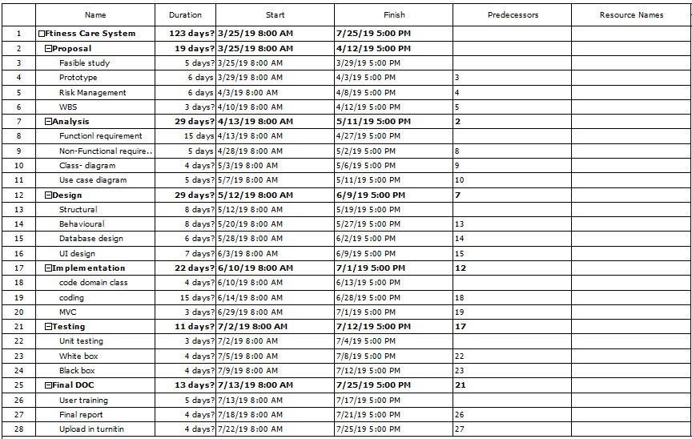

Figure : Days division for task

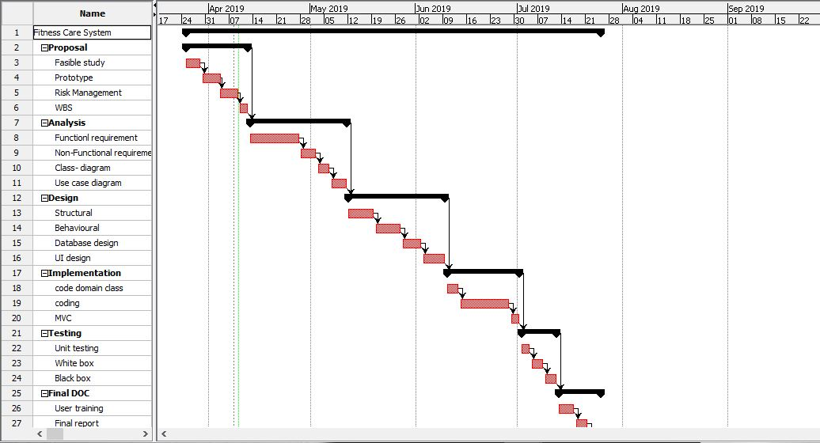

Figure : Gantt chart for project

# Chapter 5

**5.** Risk Management:

It is a process of identification, evalution and prioritization of risk in project. It is a part of project to figure out the risk in the project. Risk management different strategies and process. It also help to find out the proper way to deal with enlisted risk. Some of the strategies of risk management are:

* Risk identification
* Risk analysis
* Risk assessment and evalution
* Risk mitigation
* Risk monitoring

Impact = likelihood * consequence

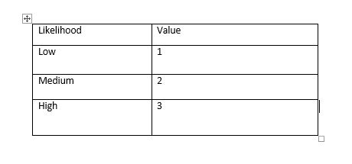

Figure : Likelihood

Risk consequence values are shown below:

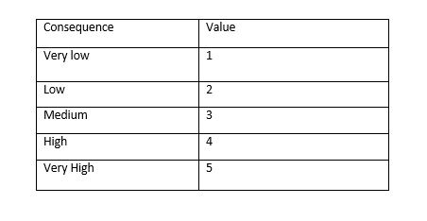

Figure : Consequence

Risk Consequence values are shown below:

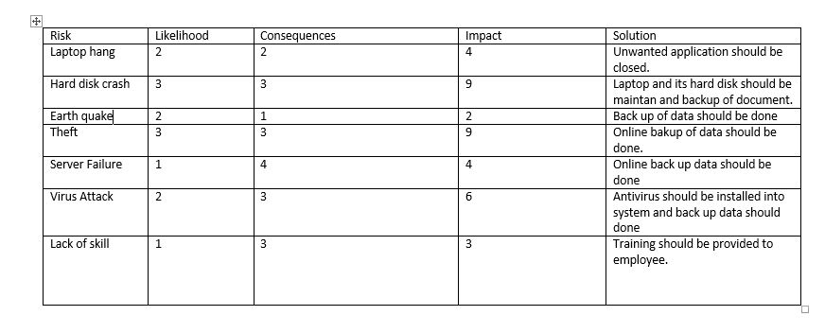

Figure : Risk Consequences

# Chapter 6

**6.** Configuration Management:

It is a systems engineering process for creating and maintaining consistency of a product’s performance, functional and physical attributes with its requirement, design and operational information throughout life. It seeks to identify and track individual configuration terms, documentig functional capabilities and interdependencies.

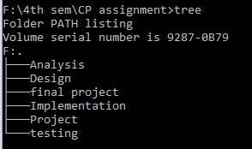

Figure : Tree structure of MBS

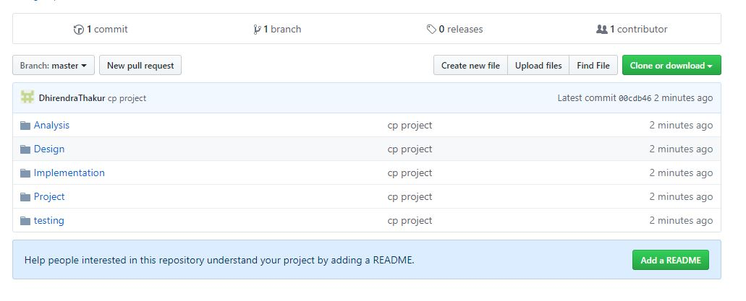

Figure : MBS on GitHub

# Chapter 7

# Conclusion:

This software is built to record data of the user as well as to provide the information of workout plan and diet paln. Fitness care system is user friendly desktop application. In future online payment will be added in the application. This software follow MVC pattern as well as waterfall model then suitable breakdown and scheduling are done properly.

# Chapter 8:

# Referencces:

1. <https://sourcemaking.com/design_patterns>
2. <https://www.workbreakdownstructure.com/>
3. <https://proplibrary.com/proplibrary/item/30-do-you-have-a-work-breakdown-structure-or-flow-chart-for-the-proposal-process/>
4. <https://www.workbreakdownstructure.com/>
5. <https://searchcompliance.techtarget.com/definition/risk-management>
6. <http://www.businessdictionary.com/definition/system-architecture.html>
7. <https://techbeacon.com/app-dev-testing/top-5-software-architecture-patterns-how-make-right-choice>